Test Cases Document
CST8513: Quality Assurance and Testing
Assignment II — System Testing Strategy
Application: PrestaShop (Customer Journey)
Professor: Marwan Farah
March 27, 2026

Prepared by:
Robert Ohly — 041092144
Daniel Bierman — 041106553
Michael Dagher — 041088202
Nicholas Jacques — 041110677

1. Introduction
This document contains the full set of test cases for the PrestaShop customer journey, based on the System requirements (FR-01 through FR-11) defined in Phase I. Cases cover System Testing and Integration Testing.

2. Test Case Summary
TC ID | Test Name | Linked FR | Level | Priority | Name
TC-01-01 | Successful Account Registration with Valid Inputs | FR-01 | System Testing | High | Robert
TC-01-02 | Registration Rejected for Duplicate Email Address | FR-01 | System Testing | High | Robert
TC-01-03 | Registration Rejected for Missing Required Fields | FR-01 | System Testing | High | Robert
TC-02-01 | Successful Login with Valid Credentials | FR-02 | System Testing | High | Robert
TC-02-02 | Login Rejected with Invalid Credentials | FR-02 | System Testing | High | Robert
TC-02-03 | Successful Logout Clears Session | FR-02 | System Testing | High | Robert
TC-03-01 | Browse Products by Category | FR-03 | System Testing | High | Robert
TC-03-02 | Filter Products by Price Range | FR-03 | System Testing | High | Robert
TC-03-03 | Sort Products by Price Ascending | FR-03 | System Testing | Medium | Robert
TC-03-04 | Filter Products by Colour | FR-03 | System Testing | Medium | Robert
TC-04-01 | Search Returns Relevant Results for Valid Keyword | FR-04 | System Testing | High | Robert
TC-04-02 | Search Displays No Results Message for Unmatched Query | FR-04 | System Testing | High | Robert
TC-05-01 | Product Detail Page Displays All Required Information | FR-05 | System Testing | Medium | Nick
TC-05-02 | Out-of-Stock Product Cannot Be Added to Cart | FR-05 | System Testing | Medium | Nick
TC-06-01 | Add Item to Cart with Valid Quantity | FR-06 | System Testing | High | Nick
TC-06-02 | Adding Quantity Exceeding Stock is Rejected | FR-06 | System Testing | High | Nick
TC-07-01 | Update Item Quantity in Cart Updates Total | FR-07 | System Testing | High | Nick
TC-07-02 | Remove Item from Cart | FR-07 | System Testing | High | Nick
TC-07-03 | Empty Cart Displays Appropriate Message | FR-07 | System Testing | Medium | Daniel
TC-08-01 | Complete Multi-Step Checkout Successfully | FR-08 | System Testing | High | Daniel
TC-08-02 | Checkout Blocked When Required Fields Are Incomplete | FR-08 | System Testing | High | Daniel
TC-08-03 | Unauthenticated User can Complete Checkout | FR-08 | System Testing | High | Daniel
TC-09-01 | Order Confirmation Page Displays After Successful Purchase | FR-09 | System Testing | High | Daniel
TC-10-01 | Logged-In User Can View Order History | FR-10 | System Testing | Medium | Daniel
TC-10-02 | Order History Not Accessible When Logged Out | FR-10 | System Testing | Medium | Daniel
TC-11-01 | Update Personal Information Successfully | FR-11 | System Testing | Medium | Daniel
TC-11-02 | Profile Update Rejected for Invalid Email Format | FR-11 | System Testing | Medium | Daniel
TC-11-03 | Password Change Requires Current Password Confirmation | FR-11 | System Testing | Medium | Michael
TC-INT-01 | Cart Items Persist After Login | FR-06, FR-07, FR-02 | Integration Testing | High | Michael
TC-INT-02 | Cart Total Updates Correctly After Quantity Change | FR-06, FR-07 | Integration Testing | High | Michael
TC-INT-03 | Order Recorded in History After Checkout | FR-08, FR-09, FR-10 | Integration Testing | High | Michael

3. Detailed Test Cases

3.1 FR-01 — User Registration
TC-01-01 | Successful Account Registration with Valid Inputs
Linked FR(s) | FR-01
Test Level | System Testing
Priority | High
Preconditions | User is not logged in  No existing account with the email being used  Browser is open to the PrestaShop homepage
Test Steps | 1. Click 'Sign in' in the top navigation bar.  2. Click 'No account? Create one here'.  3. Enter a valid first name, last name, email address, and password.  4. Click 'Save'.
Expected Result | Account is created successfully.  User is redirected to the account dashboard.  A confirmation or welcome message is displayed.
Actual Result | Account Created. Name Displayed at top of page.
Pass / Fail | Success
Notes | Selected Mr., entered birthdate, used password WgCkpH0uEYWm7yx, agreed to TOC & Customer data privacy.

TC-01-02 | Registration Rejected for Duplicate Email Address
Linked FR(s) | FR-01
Test Level | System Testing
Priority | High
Preconditions | An account already exists with the email 'existing@example.com'  User is not logged in
Test Steps | 1. Navigate to the account creation page.  2. Enter a valid first name and last name.  3. Enter 'existing@example.com' as the email.  4. Enter a valid password and click 'Save'.
Expected Result | Account creation is rejected.  An error message indicates the email is already in use.  User is not redirected to the dashboard.
Actual Result | Displayed the warning message:  The email is already used, please choose another one or sign in
Pass / Fail | Pass
Notes | Had to manually create account with existing@example.com first.  Creating the second account with the same email yielded the error.  Used Mr, Valid First Name, Valid Last Name, existing@example.com, and WgCkpH0uEYWm7yx for both accounts.

TC-01-03 | Registration Rejected for Missing Required Fields
Linked FR(s) | FR-01
Test Level | System Testing
Priority | High
Preconditions | User is not logged in  User is on the account creation page
Test Steps | 1. Leave the email field blank.  2. Fill in all other required fields.  3. Click 'Save'.
Expected Result | Form submission is prevented.  A validation error highlights the missing field.  No account is created.
Actual Result | Yielded please fill out this field with an exclamation mark in a amber square symbol below the email field
Pass / Fail | Pass
Notes | Used Mr, Valid First Name, Valid Last Name, and WgCkpH0uEYWm7yx for fields.

3.2 FR-02 — Login / Logout
TC-02-01 | Successful Login with Valid Credentials
Linked FR(s) | FR-02
Test Level | System Testing
Priority | High
Preconditions | A registered account exists with known credentials  User is not logged in
Test Steps | 1. Click 'Sign in' in the top navigation bar.  2. Enter the registered email and correct password.  3. Click 'Sign in'.
Expected Result | User is redirected to the account dashboard within 2 seconds.  Navigation shows user name or sign-out option.  No error messages are displayed.
Actual Result | Signed in
Pass / Fail | Pass
Notes | Reused the credentials from TC-01-01

TC-02-02 | Login Rejected with Invalid Credentials
Linked FR(s) | FR-02
Test Level | System Testing
Priority | High
Preconditions | User is not logged in  User is on the login page
Test Steps | 1. Enter a valid email that has an account.  2. Enter an incorrect password.  3. Click 'Sign in'.
Expected Result | Login is rejected.  An error message does not specify which field is wrong.  User remains on the login page.
Actual Result | Entered rjohly@gmail.com and redfish99 and the login yielded the error message.  Authentication failed.
Pass / Fail | Pass
Notes | Reused the credentials from TC-01-01, but substituted the password for redfish99

TC-02-03 | Successful Logout Clears Session
Linked FR(s) | FR-02
Test Level | System Testing
Priority | High
Preconditions | User is currently logged in
Test Steps | 1. Click the logout option in the account menu.  2. After logout, attempt to navigate directly to the account dashboard URL.
Expected Result | User is logged out and redirected to the homepage.  Accessing the dashboard URL redirects to the login page.  No session data persists.
Actual Result | Successfully logged and navigated to generic dashboard
Pass / Fail | Pass
Notes | Logged in using credentials from TC-01-01

3.3 FR-03 — Product Browsing
TC-03-01 | Browse Products by Category
Linked FR(s) | FR-03
Test Level | System Testing
Priority | High
Preconditions | User is on the homepage  Product catalogue has multiple categories
Test Steps | 1. Click on a category in the navigation menu (e.g., 'Clothes').  2. Observe the product listing page.  3. Click a sub-category if available.
Expected Result | Products relevant to the selected category are displayed.  Each product shows a name, image, and price.  Sub-category navigation further filters results correctly.
Actual Result | Correctly filtered
Pass / Fail | Pass
Notes | Home/Accessories/Stationery only shows notebooks as expected

TC-03-02 | Filter Products by Price Range
Linked FR(s) | FR-03
Test Level | System Testing
Priority | High
Preconditions | User is on a product listing page with a price filter panel  Multiple products with varying prices are listed
Test Steps | 1. Adjust the price range slider to a narrow range (e.g., $11–$30).  2. Apply the filter.  3. Observe the results.
Expected Result | Only products within the specified price range are displayed.  Products outside the range are hidden.  The product count updates accordingly.
Actual Result | Correctly Filtered.
Pass / Fail | Pass
Notes | Home/Accessories. Set the price range of €18 to €20. Displayed Brown Bear, Mountain Fox, and Hummingbird Cushions which all cost €18.90

TC-03-03 | Sort Products by Price Ascending
Linked FR(s) | FR-03
Test Level | System Testing
Priority | Medium
Preconditions | User is on a product listing page with multiple items
Test Steps | 1. Select 'Price, low to high' from the sort dropdown.  2. Observe the product order.
Expected Result | Products reorder from lowest to highest price.  The order is consistent with the prices displayed.
Actual Result | “Price, low to high” sorted by price in ascending order.
Pass / Fail | Pass
Notes | Home/Accessories. First item was “Mug Today Is A Good Day” for €11.9 and the last item was “Pack Mug + Frame Poster” for €35.00

TC-03-04 | Filter Products by Color
Linked FR(s) | FR-03
Test Level | System Testing
Priority | Medium
Preconditions | User is on a category listing page that supports color filtering
Test Steps | 1. In the left filter panel, select a color (e.g., 'Blue').  2. Observe the product listing.
Expected Result | Only products available in the selected color are shown.  Products not available in that color are removed from the listing.
Actual Result | Only showed black items when filtering for black.
Pass / Fail | Pass
Notes | Home/Accessories. Displayed Black; Brown Bear, Mountain Fox, and Hummingbird Cushions

3.4 FR-04 — Product Search
TC-04-01 | Search Returns Relevant Results for Valid Keyword
Linked FR(s) | FR-04
Test Level | System Testing
Priority | High
Preconditions | User is on the storefront  At least one product matching the keyword exists
Test Steps | 1. Click the search bar.  2. Type a valid keyword (e.g., 'shirt').  3. Press Enter.
Expected Result | Products matching the keyword are displayed.  Each result shows a name, image, and price.  Search completes within 2 seconds.
Actual Result | Displayed one item for “shirt”
Pass / Fail | Pass
Notes | Entered “shirt” into the homepage search. “Hummingbird printed t-shirt" and its associated image was displayed showing a price of €23.90, discounted by 20% down to €19.12.

TC-04-02 | Search Displays No Results Message for Unmatched Query
Linked FR(s) | FR-04
Test Level | System Testing
Priority | High
Preconditions | User is on the storefront
Test Steps | 1. Click the search bar.  2. Type a keyword unlikely to match any product (e.g., 'xyzqwerty999').  3. Press Enter.
Expected Result | A 'no results found' message is clearly displayed.  No products are shown.  The page does not error out.
Actual Result | No matches were provided and a secondary search with “xyzqwerty999” appeared.  No matches were found for your search  Please try other keywords to describe what you are looking for.
Pass / Fail | Pass
Notes | Searching for “bob” on the other hand did return results, but this was likely due to fuzzy search matching rather than strict matching or start of word comparison.

3.5 FR-05 — Product Details
TC-05-01 | Product Detail Page Displays All Required Information
Linked FR(s) | FR-05
Test Level | System Testing
Priority | Medium
Preconditions | User is on a product listing page
Test Steps | 1. Click on any product.  2. Observe the product detail page.
Expected Result | Page displays: product name, description, price, at least one image, and stock availability.  All information is accurate and readable.
Actual Result | 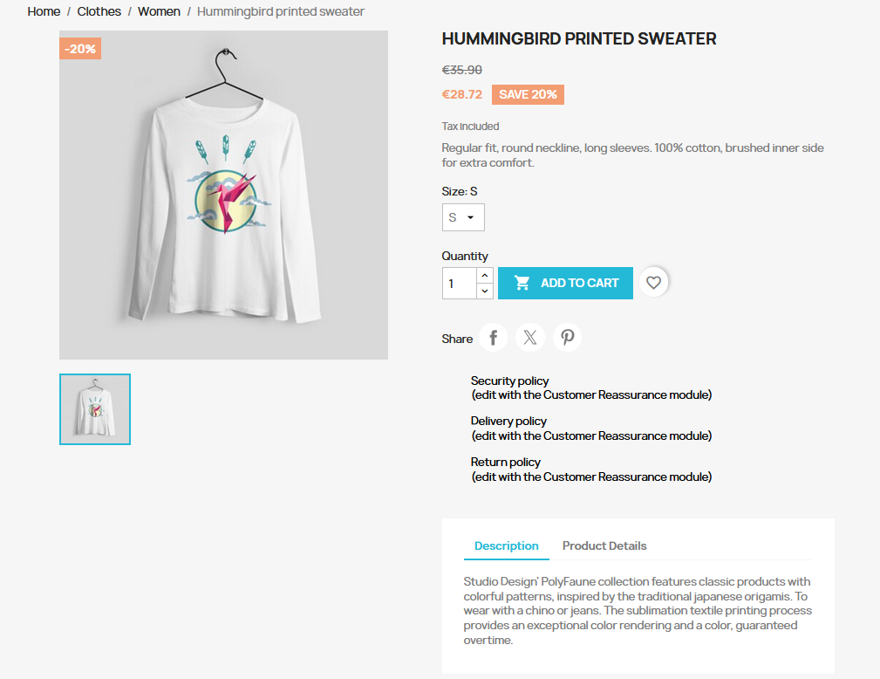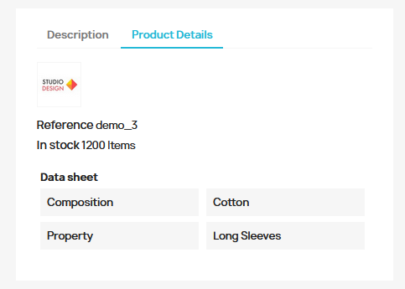  Found product name, description, price, one image, and stock availability. All information is accurate and readable.
Pass / Fail | Pass
Notes | Used Hummingbird Printed Sweater Product for test.

TC-05-02 | Out-of-Stock Product Cannot Be Added to Cart
Linked FR(s) | FR-05
Test Level | System Testing
Priority | Medium
Preconditions | At least one product in the catalogue is marked as out of stock
Test Steps | 1. Navigate to an out-of-stock product.  2. Observe the product detail page.  3. Attempt to click 'Add to Cart'.
Expected Result | The product page clearly indicates it is out of stock.  The 'Add to Cart' button is disabled or absent.  No item is added to the cart.
Actual Result | 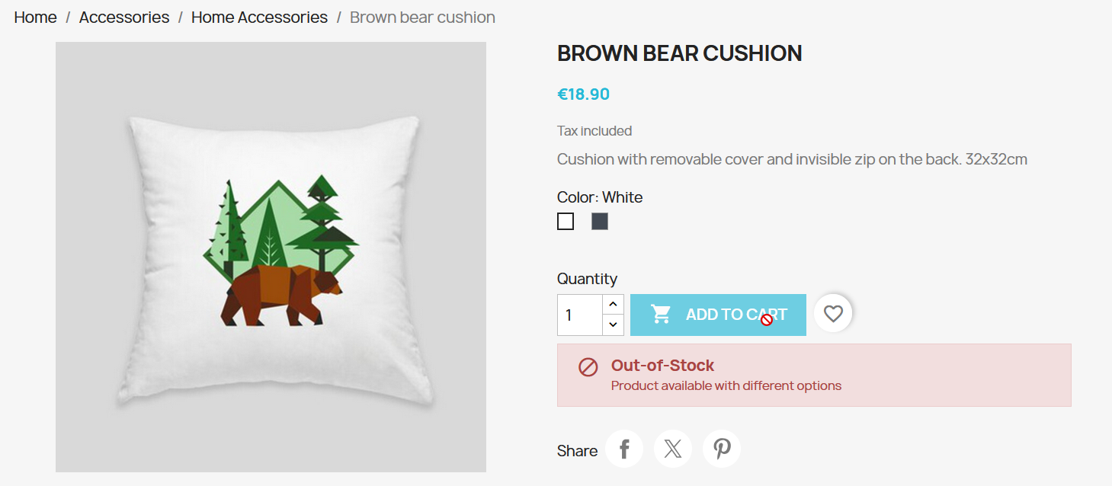There was clear indication the item is out of stock and the add to cart button was disabled. I could not add it to the cart.
Pass / Fail | Pass
Notes | Items in stock do not display the out-of-stock message and can be added to the cart.

3.6 FR-06 — Add to Cart
TC-06-01 | Add Item to Cart with Valid Quantity
Linked FR(s) | FR-06
Test Level | System Testing
Priority | High
Preconditions | User is on the product detail page of an in-stock item
Test Steps | 1. Set the quantity to 2.  2. Click 'Add to Cart'.  3. Navigate to the cart.
Expected Result | The item appears in the cart with quantity 2.  The cart total reflects the correct price (unit price x 2).  The cart icon updates to show the correct quantity.
Actual Result | 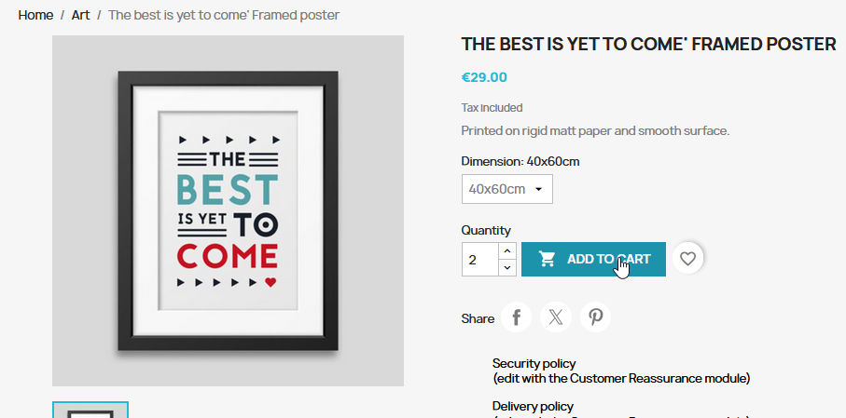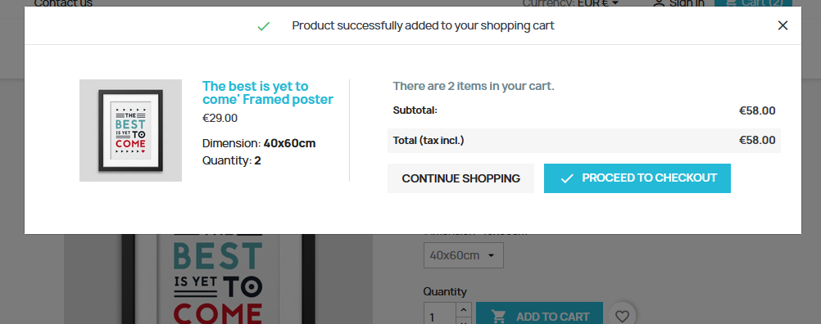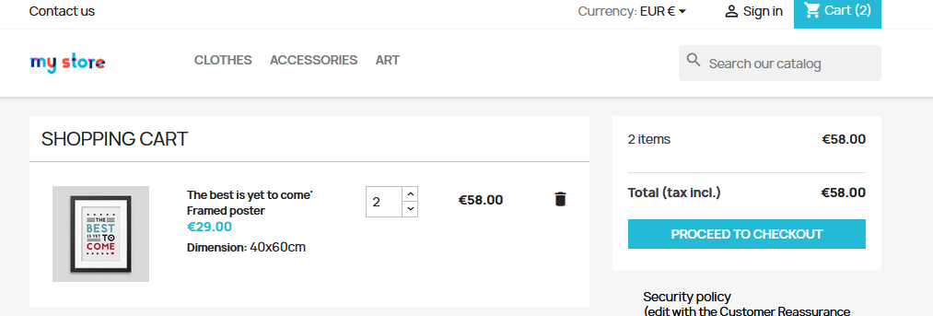  - I was able to set quantity to 2 and add to cart.  - The shopping cart correctly showed the quantity as 2 in the icon in the nav bar and on the shopping cart page.  - Total was correct: unit price (29) x 2 = 58.
Pass / Fail | Pass
Notes | N/A

TC-06-02 | Adding Quantity Exceeding Stock is Rejected
Linked FR(s) | FR-06
Test Level | System Testing
Priority | High
Preconditions | User is on a product detail page of an item with limited stock
Test Steps | 1. Set the quantity to a value higher than available stock (e.g., 999).  2. Click 'Add to Cart'.
Expected Result | An error message is displayed indicating the quantity exceeds available stock.  The cart is not updated with the invalid quantity.
Actual Result | 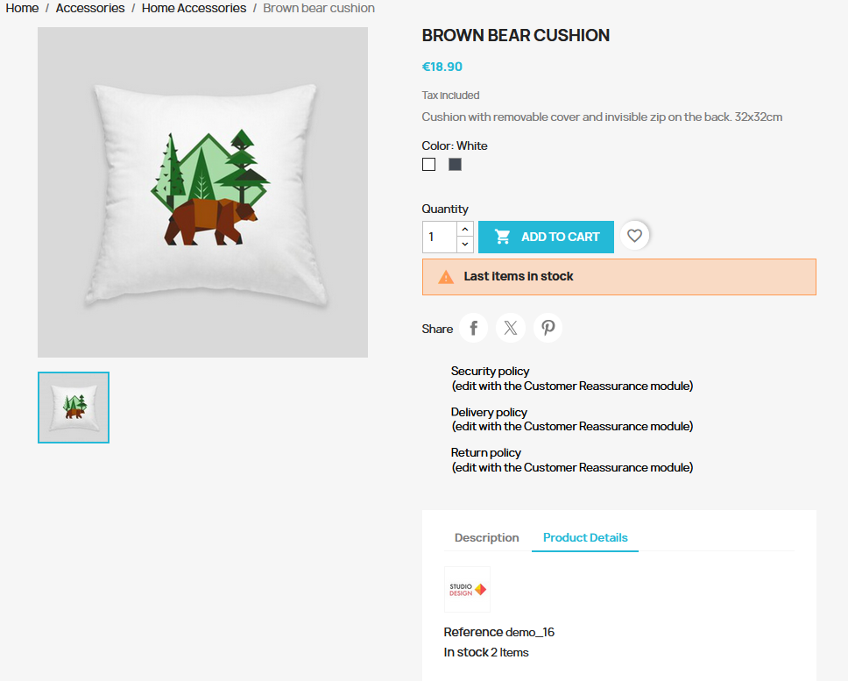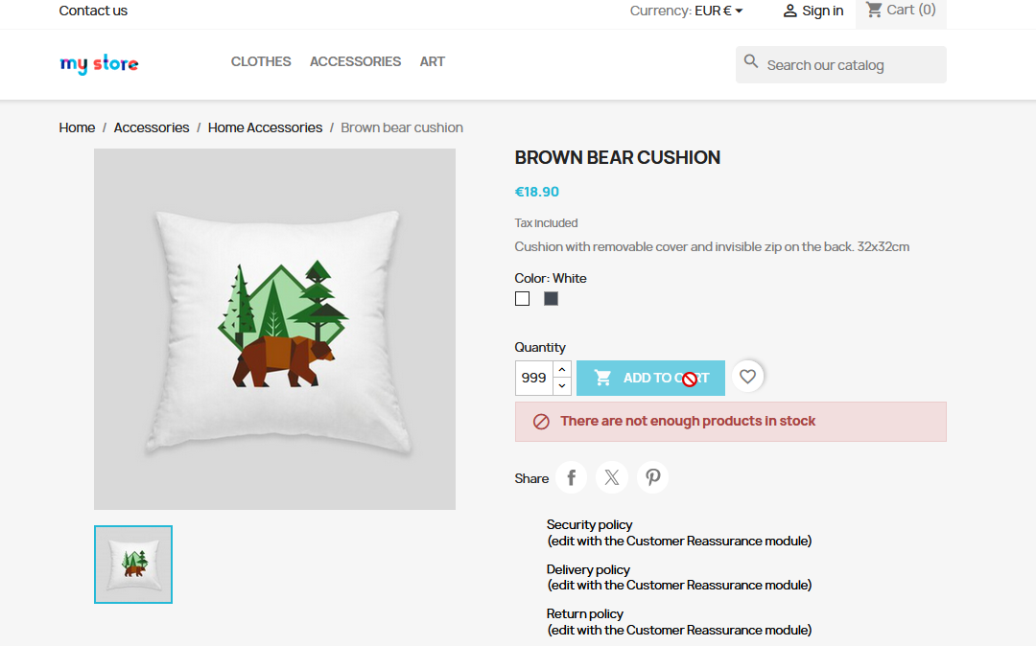An error message appeared when I typed in “999” into the quantity field and the Add to Cart button was disabled. I could not add it to the cart, and the cart remained empty.
Pass / Fail | Pass
Notes | The specific message that appears is “There are not enough products in stock” and it happens on the details page immediately before a user can add it to their cart.

3.7 FR-07 — Cart Management
TC-07-01 | Update Item Quantity in Cart Updates Total
Linked FR(s) | FR-07
Test Level | System Testing
Priority | High
Preconditions | User has at least one item in the cart  User is on the cart page
Test Steps | 1. Change the quantity of an item from 1 to 3.  2. Confirm or apply the change.
Expected Result | The cart total updates to reflect the new quantity.  The line item total for that product updates correctly.
Actual Result | 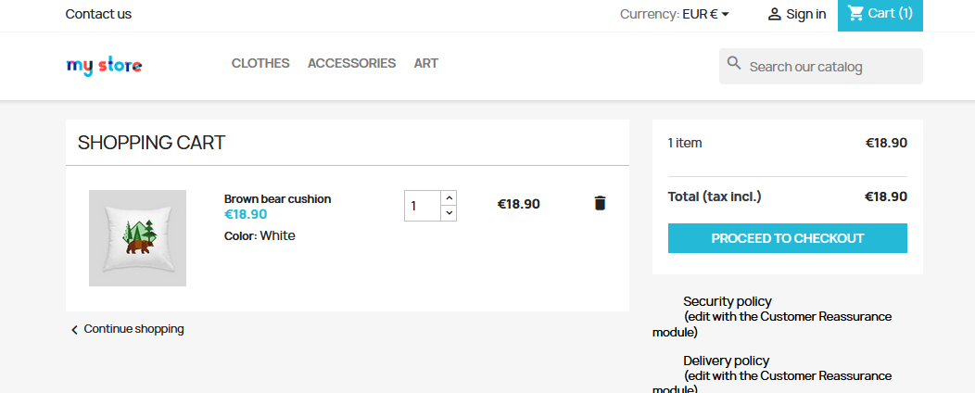Change to 2:  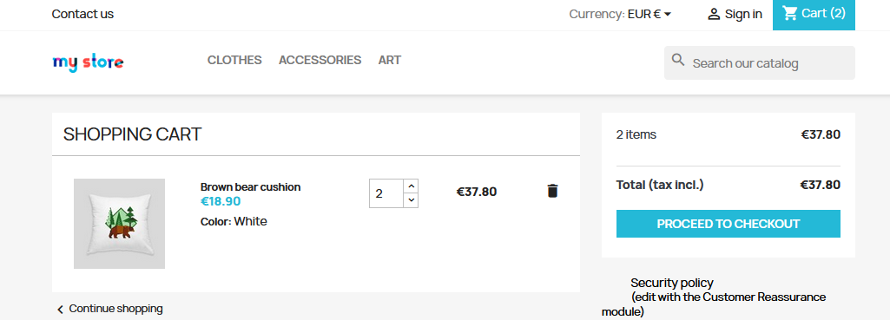I can change the quantity on the cart page and it updates the line total correctly  18.90 x 2 = 37.80
Pass / Fail | Pass
Notes | 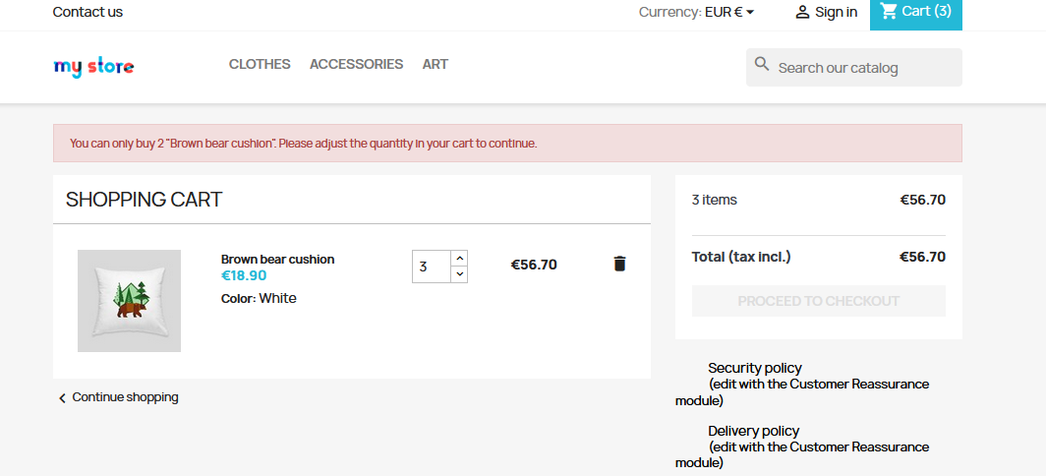This item only has 2 items in stock. I was allowed to exceed that but the proceed to checkout button became disabled and an error message appeared. This is consistent with exceeding stock on the product details page and successfully blocks customers from ordering more than the available stock.

TC-07-02 | Remove Item from Cart
Linked FR(s) | FR-07
Test Level | System Testing
Priority | High
Preconditions | User has at least one item in the cart  User is on the cart page
Test Steps | 1. Click the remove button next to a cart item.  2. Observe the cart.
Expected Result | The item is removed from the cart immediately.  The cart total updates accordingly.
Actual Result | 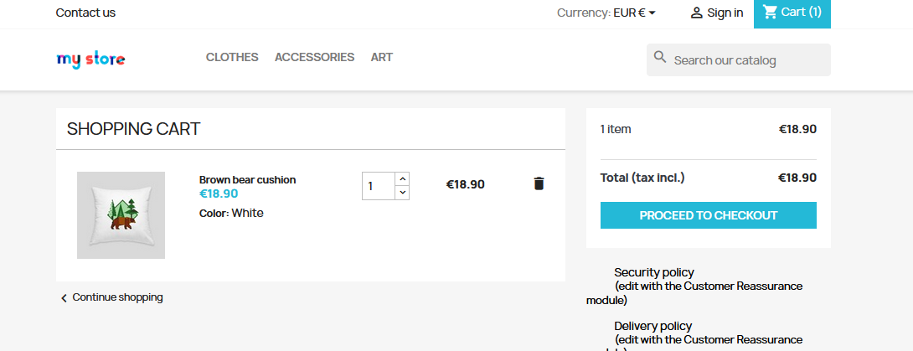I had the bear cushion in stock, then i pressed the garbage icon to delete it.  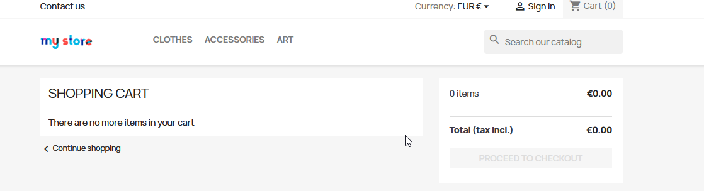The item disappeared immediately without issues, and the cart total and number of items were updated correctly.
Pass / Fail | Pass
Notes | We could look at performance testing this type of scenario (removing large quantities from the cart) but, from manual testing, it performs well from the user perspective.

TC-07-03 | Empty Cart Displays Appropriate Message
Linked FR(s) | FR-07
Test Level | System Testing
Priority | Medium
Preconditions | User's cart is empty
Test Steps | 1. Navigate to the cart page with no items.
Expected Result | A clear message is displayed indicating the cart is empty.  No product rows or pricing information are shown.
Actual Result | 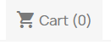  Cart(0) is displayed – correct.
Pass / Fail | PASS
Notes

3.8 FR-08 — Checkout
TC-08-01 | Complete Multi-Step Checkout Successfully
Linked FR(s) | FR-08
Test Level | System Testing
Priority | High
Preconditions | User is logged in  User has at least one item in the cart  User has a valid shipping address
Test Steps | 1. Click 'Proceed to Checkout' from the cart.  2. Enter or select a valid shipping address. Click 'Continue'.  3. Select a delivery method. Click 'Continue'.  4. Enter valid payment information.  5. Review the order summary and click 'Place Order'.
Expected Result | All steps are presented in sequence.  User progresses through each step without errors.  An order confirmation is displayed after submission.
Actual Result | 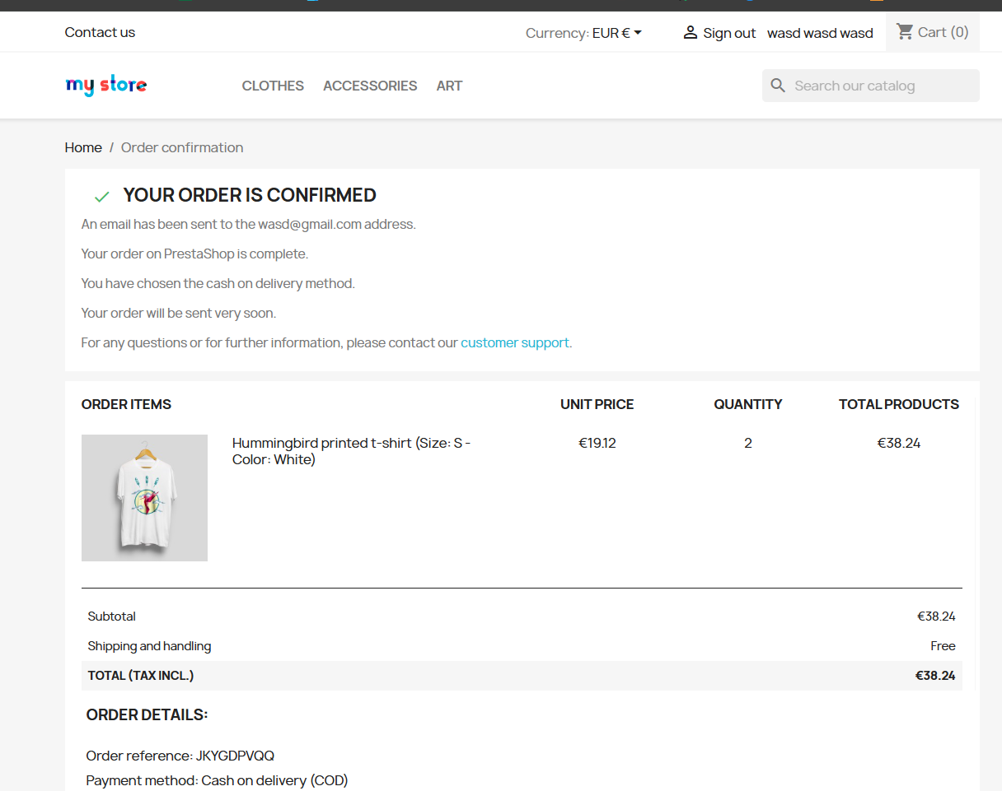
Pass / Fail | PASS
Notes | Had to update the backend to allow for shipping to non-existent addresses, but now the complete transaction process works.

TC-08-02 | Checkout Blocked When Required Fields Are Incomplete
Linked FR(s) | FR-08
Test Level | System Testing
Priority | High
Preconditions | User is logged in with items in cart  User is on the checkout shipping address step
Test Steps | 1. Leave the 'Address' field blank.  2. Fill in all other required fields.  3. Click 'Continue'.
Expected Result | The checkout does not advance to the next step.  A validation error is shown indicating the missing field.  No order is submitted.
Actual Result | 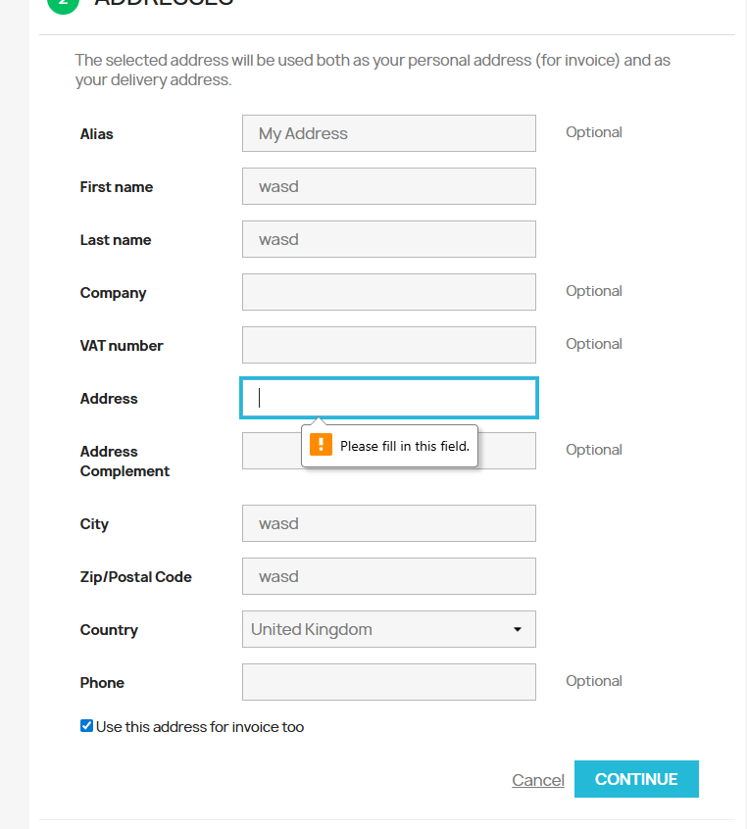
Pass / Fail | PASS
Notes | You are blocked from continuing unless you put something in the address field.

TC-08-03 | Unauthenticated User can Complete Checkout
Linked FR(s) | FR-08
Test Level | System Testing
Priority | High
Preconditions | User is not logged in  User has added items to the cart as a guest
Test Steps | 1. Navigate to the cart.  2. Click 'Proceed to Checkout'.
Expected Result | User is allowed to purchase the items and is prompted to create an account after completing the transaction.
Actual Result | 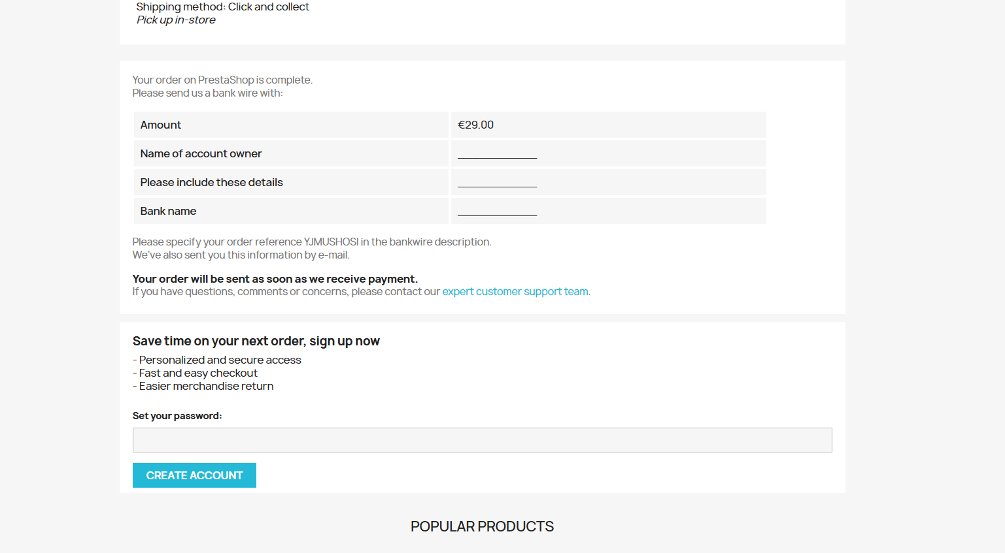
Pass / Fail | PASS
Notes | I was prompted to create a password twice in the transaction process – once before when entering my name / address, and again on the order confirmation screen.

3.9 FR-09 — Order Confirmation
TC-09-01 | Order Confirmation Page Displays After Successful Purchase
Linked FR(s) | FR-09
Test Level | System Testing
Priority | High
Preconditions | User has successfully completed the checkout process
Test Steps | 1. Complete a full checkout flow.  2. Observe the page displayed after order placement.
Expected Result | An order confirmation page is displayed within 3 seconds.  The page includes: a unique order number, itemized product list, order total, and estimated delivery.
Actual Result | 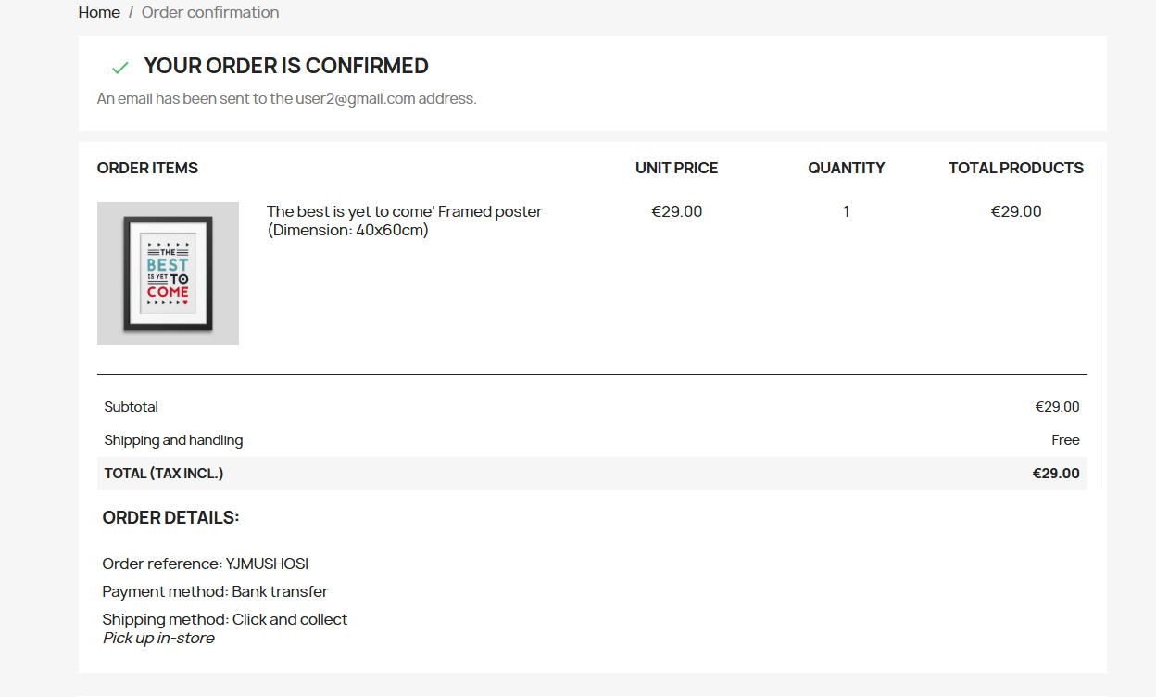
Pass / Fail | PASS
Notes | Order confirmation screen displays correctly.

3.10 FR-10 — Order History
TC-10-01 | Logged-In User Can View Order History
Linked FR(s) | FR-10
Test Level | System Testing
Priority | Medium
Preconditions | User is logged in  User has placed at least one previous order
Test Steps | 1. Navigate to 'My Account'.  2. Click 'Order History' or 'My Orders'.
Expected Result | Past orders are listed with order number, date, status, and item summary.  Clicking an order reveals full details.
Actual Result | 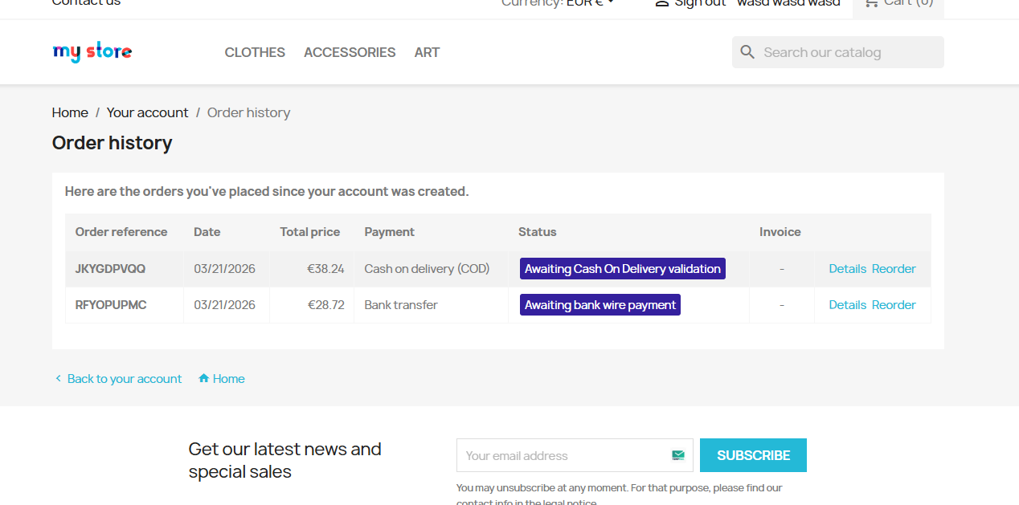
Pass / Fail | PASS
Notes

TC-10-02 | Order History Not Accessible When Logged Out
Linked FR(s) | FR-10
Test Level | System Testing
Priority | Medium
Preconditions | User is not logged in
Test Steps | 1. Attempt to navigate directly to the order history URL.
Expected Result | User is redirected to the login page.  Order history data is not shown to unauthenticated users.
Actual Result | 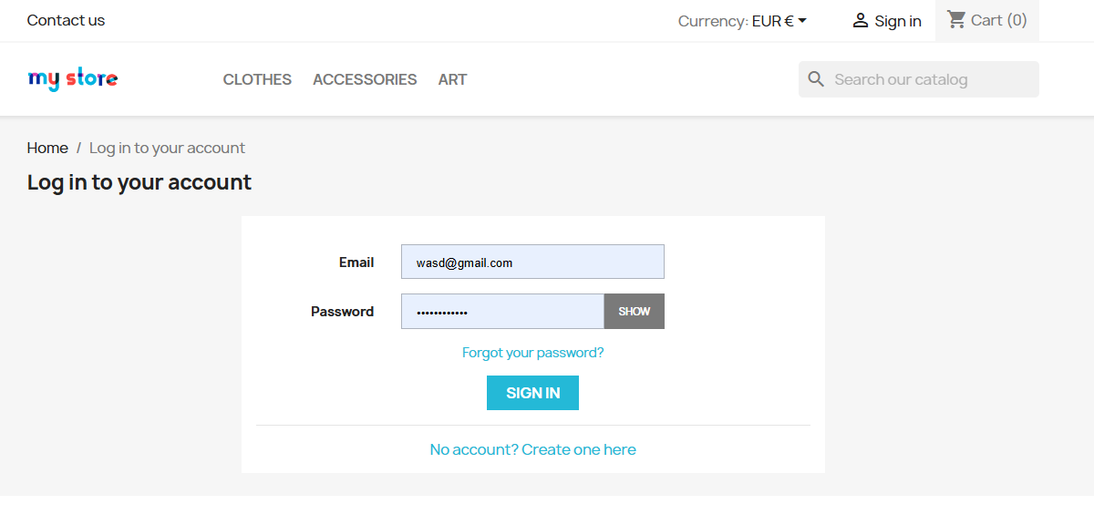I was redirected to the login page.
Pass / Fail | PASS
Notes | This is technically a pass for this test case, however, in testing this I found something else. While the order history page is not accessible while signed out, the order confirmation page is:  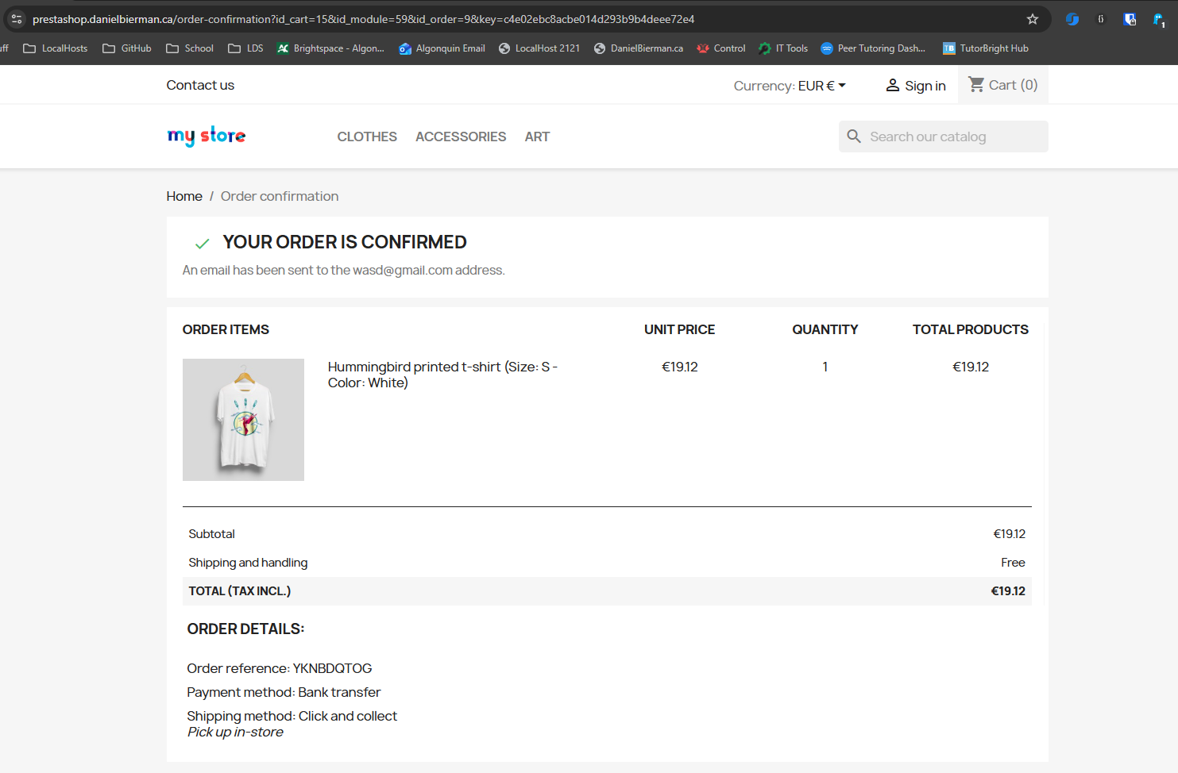After signing out I was able to refresh the page and still view this order confirmation page.  On further thought into this this may have been intentional in order to allow users to share an order confirmation screen with other users.  Linked Defect: DEF-001

3.11 FR-11 — Profile Management
TC-11-01 | Update Personal Information Successfully
Linked FR(s) | FR-11
Test Level | System Testing
Priority | Medium
Preconditions | User is logged in  User is on the personal information edit page
Test Steps | 1. Change the first name to a new value.  2. Enter the current password to confirm.  3. Click 'Save'.
Expected Result | Changes are saved successfully.  A confirmation message is displayed.  The updated name is reflected in the account.
Actual Result | 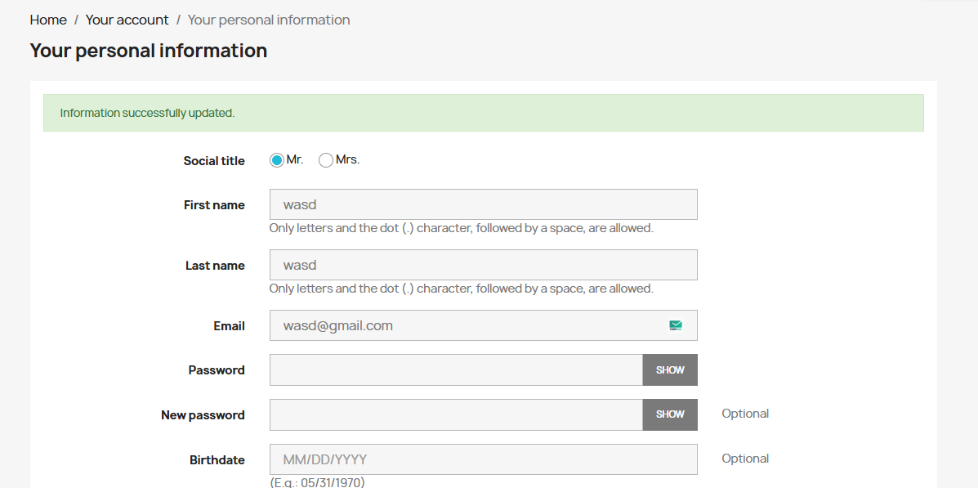
Pass / Fail | PASS
Notes | Information updates as expected.  Once annoyance is that I have to retype my password every time, even if only updating my name.

TC-11-02 | Profile Update Rejected for Invalid Email Format
Linked FR(s) | FR-11
Test Level | System Testing
Priority | Medium
Preconditions | User is logged in  User is on the personal information edit page
Test Steps | 1. Clear the email field and enter a malformed address (e.g., 'notanemail').  2. Click 'Save'.
Expected Result | The update is rejected.  A validation error indicates the email format is invalid.  No changes are saved.
Actual Result | 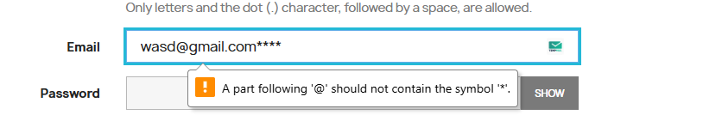
Pass / Fail | PASS
Notes | Email Validation worked well.

TC-11-03 | Password Change Requires Current Password Confirmation
Linked FR(s) | FR-11
Test Level | System Testing
Priority | Medium
Preconditions | User is logged in  User is on the password change section
Test Steps | 1. Enter a new password without entering the current password.  2. Click 'Save'.
Expected Result | The password change is rejected.  An error indicates the current password is required.  Password is not changed.
Actual Result | 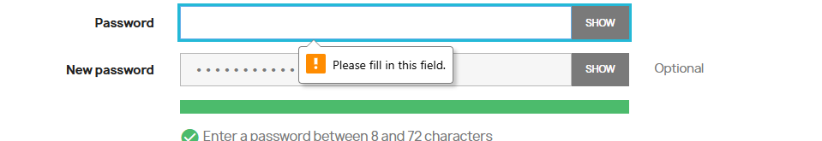
Pass / Fail | PASS
Notes

3.12 Integration Test Cases
TC-INT-01 | Cart Items Persist After Login
Linked FR(s) | FR-06, FR-07, FR-02
Test Level | Integration Testing
Priority | High
Preconditions | User is not logged in
Test Steps | 1. Add one or more items to the cart as a guest.  2. Log in with valid credentials.  3. Navigate to the cart.
Expected Result | Items added as a guest are still present in the cart after login.  Quantities and item details are preserved.
Actual Result | 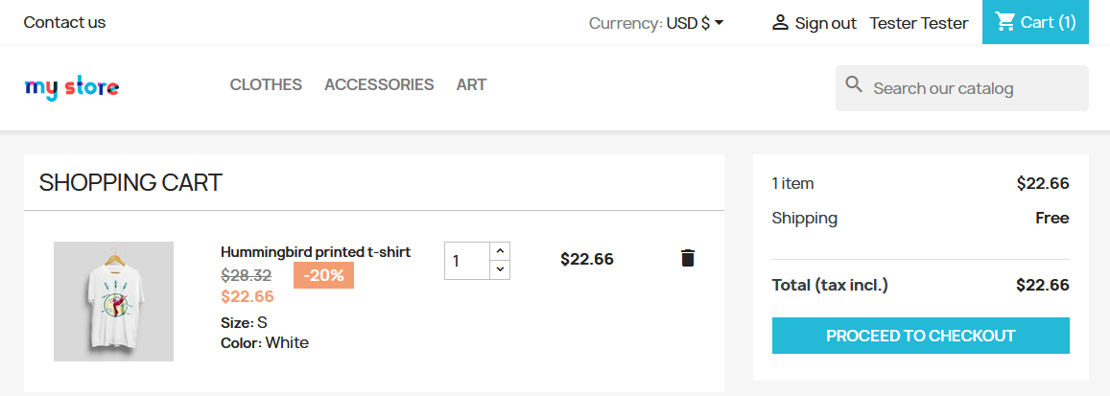
Pass / Fail | PASS
Notes

TC-INT-02 | Cart Total Updates Correctly After Quantity Change
Linked FR(s) | FR-06, FR-07
Test Level | Integration Testing
Priority | High
Preconditions | User has multiple items in the cart
Test Steps | 1. Note the current cart total.  2. Increase the quantity of one item by 1.  3. Observe the new cart total.
Expected Result | The cart total updates immediately.  New total = old total + unit price of the changed item.
Actual Result | 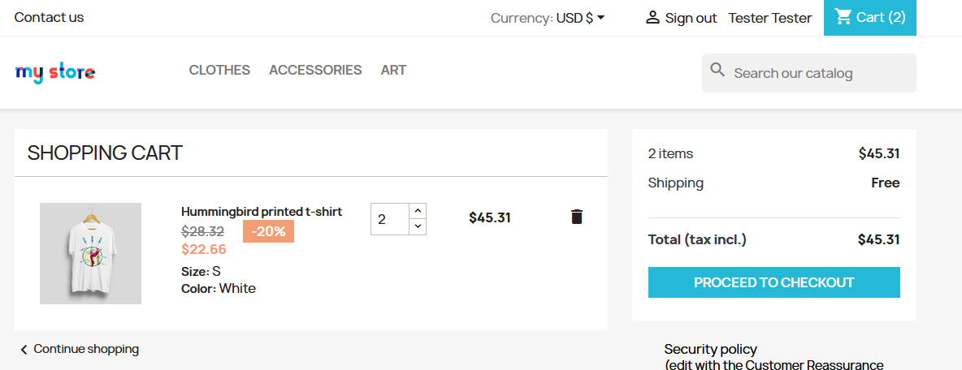
Pass / Fail | PASS
Notes | It takes a moment after you update the quantity, not quite instant.

TC-INT-03 | Order Recorded in History After Checkout
Linked FR(s) | FR-08, FR-09, FR-10
Test Level | Integration Testing
Priority | High
Preconditions | User is logged in  User has just placed an order
Test Steps | 1. Note the order number from the confirmation page.  2. Navigate to 'My Account' > 'Order History'.  3. Search for the order.
Expected Result | The new order appears in order history with the correct order number.  Status, items, and total match the confirmation page.
Actual Result | 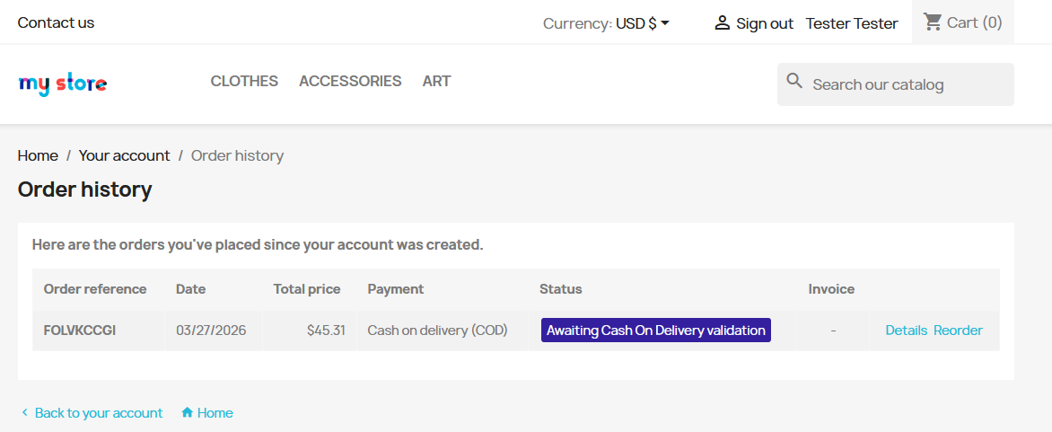
Pass / Fail | PASS
Notes

